Available online at [www.sciencedirect.com](http://www.sciencedirect.com/)



AASRI Procedia 3 (2012) 540 – 545

2012 AASRI Conference on Modeling, Identification and Control

Microscopic three-dimensional measurement system design

Changjiang Songa,*, Na Xinga, Gang Wua

*aThe Institute of Automation of Heilongjiang Academy of Sciences, Hanshui road No. 165 Harbin 150090, China*

Abstract

Micro stereo vision system is widely used in the field of microscopic research due to its high-precision 3D measurement and positioning by visual feedback. High-precision measurement data can provide advanced observation and analysis for scientific research and industrial applications. The study reconstructed three-dimensional information of objects accurately in microscopic viewing by combining phase shift technology with optical microscopy technique. This paper focused on the technology of phase shift, a system prototype has been developed, and we have done application tests in many fields to test the accuracy of this system, the feasibility and stability of the system has been verified.

© 2012 The Authors. Published by Elsevier B.V. Open access under [CC BY-NC-ND license.](http://creativecommons.org/licenses/by-nc-nd/3.0/)

© 2012 Published by Elsevier B.V. Selection and/or peer rev[iew under respon](http://creativecommons.org/licenses/by-nc-nd/3.0/)sibility of American Applied Science Research Institute

Selection and/or peer review under responsibility of American Applied Science Research Institute

Keywords: Stereo Light Microscope, three-dimensional measurement, structured-light imaging.

1. Introduction

Micro-vision is characterized by small shape or minimal operating scale, with the development of science and technology, it has been a high-tech for people to understand and transform the objective world in the microscopic fields [1]. Micro-vision possesses a broad application potential in many fields, and it has become an important means in micro-nanotechnology research, so it is highly valued by countries.

The operation object scale of micro-vision technology is small, it is difficult to observe, measure and assemble by traditional ways, so it requires the help of amplification equipments such as a microscope to enlarge the microscopic objects. Compared with the conventional methods, micro-vision with its features of non-contact and flexible has become a major visual monitoring and measuring method of micro operation [2].

* Corresponding author. Tel.: +86-13904613619; fax: +86-451-82342264. E-mail address: [renqi7047@sina.com.](mailto:renqi7047@sina.com)

2212-6716 © 2012 The Authors. Published by Elsevier B.V. Open access under [CC BY-NC-ND license.](http://creativecommons.org/licenses/by-nc-nd/3.0/) Selection and/or peer review under responsibility of American Applied Science Research Institute doi:10.1016/j.aasri.2012.11.085

Currently, Stereo Light Microscope(SLM) is one of the most widely used devices, it obtains stereoscopic images from two perspectives by two sub-optical paths. Due to matching accuracy and other factors, the 3D reconstruction precision of SLM is lower, which can not meet the real needs, SLM can be only used to observe the stereoscopic reality of measured objects. There are significant differences between accurate measurements and qualitative analysis, the current device is only as an auxiliary for observation, unable to meet the requirement of quantitative analysis.

Phase shift technology can calculate the 3D shape of the object surface quickly and accurately. The study combined phase shift technology with optical microscopy technique to realize the display and measurement of the deformation, space bit type and 3D microscopic contour of the microscopic object with non-contact 3D surface microstructure.

1. System
   1. *Principle of phase shifting*

With the basic principle of phase shifting, we can capture the object images when we project a specific mode lamp, such as grating, etc., to the surface measurement object. The measurement of height object can be obtained with image correlation. Structure light imaging principle in Fig 1. To be confirm the height of the reference plane is 0. Through the projection light through the grating surface of the object, we can calculate relative height point D in space position (*x*, *y*) to the reference plane:

*h*(*x*, *y*) 

**

*LCA*

 2** *D*

*(1)*

*CA P*

Where *L* is vertical distance camera reference plane. *P* is projection light wavelength in the reference plane. *D* is a distance projector to the camera. ** is just the difference of the phase from point *C* to point *A* .

*CA*

We can calculate ** as:

*CA*

*CA*  *OC*  *OA*

*(2)*

We know that phase value of the key structure light imaging from Eq.(1). The phase information of the raster image can solve three main methods: time-domain Fourier transform, convolution filtering and phase shifting. The most reliable and effective method is phase shifting, which has high capacity(or low capacity) of anti- static noise and low computational complexity. Therefore, we calculate the phase information with the method of phase shifting.

A sine raster image projected onto the object surface, we can express raster image as:

*F* ( *x*, *y*)  *F* ( *x*, *y*)  *F* ****( *x*, *y*) cos(** ( *x*, *y*)  ** ) *(3)*

Where *F* ( *x*, *y*) is the average gray level image, *F* ( *x*, *y*) is gray modulus, ** is phase modulus. We will

need at least three equations to obtain *F* ( *x*, *y*) , ** and ** ( *x*, *y*) which are not known. In our experiments, the phase increment is ** / 2 , the four steps of phase shift can be expressed as:

*F* ( *x*, *y*)  *F* ( *x*, *y*)  *F* ****( *x*, *y*) cos(** ( *x*, *y*)  ** )

1

*F* ( *x*, *y*)  *F* ( *x*, *y*)  *F* ****( *x*, *y*) sin(** ( *x*, *y*)  ** )

2

*F* ( *x*, *y*)  *F* ( *x*, *y*)  *F* ****( *x*, *y*) cos(** ( *x*, *y*)  ** )

3

*F* ( *x*, *y*)  *F* ( *x*, *y*)  *F* ****( *x*, *y*) sin(** ( *x*, *y*)  ** )

4

*(4)*



Project

CCD

D

*P*

L

3D Object

*-h*

C B

A O

Reference

Fig. 1. The principle of phase shifting imaging

From the four phase function above we can get ** ( *x*, *y*) :

** ( *x*, *y*)  tan1  *F*  *F* 

*(5)*

 4 2 

 *F*1  *F*3 

In Eq. (5), It is shown that the phase value interval distribution in [** / 2, ** / 2] . First, we need to extend the phase values to [** , ** ] with the phase values of sine and cosine, so we can gain phase value by a continuous distribution. Then, the continuous phase mapping can be searched of phase unwrapping method. Follows are the main steps:

Step 1. Establish the threshold value *R* to be approached and less than 2** , e.g. *R*  1.9** ; Step 2. Begin from *i*  0 , perform the following steps until access all of the phase value; Step 3. Computation phase difference of the points which is adjacent:

**  ** ( *x* , *y*)  ** ( *x* , *y*)

*i* 1 *i*

*i* 1 *i* 1

*(6)*

Step 4. If

**  *R* : ** ( *x* , *y*)  ** ( *x* , *y*) , else

** ( *x*

*i* 1

** ( *xi* 1 , *y*)  2** ,

, *y*)  

** ( *xi* 1 , *y*)  2** ,

*if* **  0

*if* **  0

*(7)*

Step 5. *i*  *i*  1 , do Step 3 until the end.

An example is calculated value discontinuous phase shown in Fig 2.(a). We can see a step very need discontinuous. Compared with Fig 2.(a), in Fig 2.(b), We can get a continuous phase as shown, with above five steps.

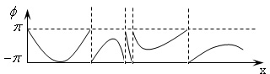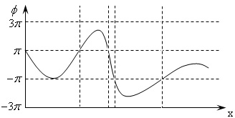

(a) (b)

Fig. 2. The phase unwrapping

* 1. *System components*

Projected a set of sinusoidal intensity grating stripes produced by the computer on the object by a projector, ingested images with CCD camera, reconstruct the surface contour of the object by phase-shift technology. As shown in Fig 3, the system is mainly constituted by a computer, microscopic stripe projector and CCD monocular microscope. The projection portion of the microscopic stripe projector and CCD optical imaging section both are with variable magnification lens, which can be applied to measuring the size of different observation.

.

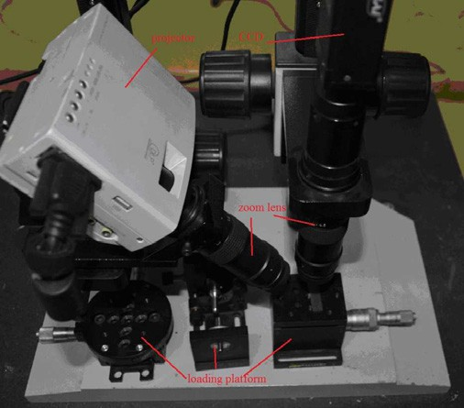

Fig. 3. Architecture of the 3D reconstruction device

1. Results

Combined four-step phase shift and encoding method with 3D sensing technology, just like projecting a set of sinusoidal intensity grating stripes produced by the computer on the object by a projector, the system projected 4 sinusoidal stripe patterns and 9 coded stripe patterns. Projected stripe will be deformed due to the depth variation of the measured surface, CCD collect the bitmap of the measured object, so as to achieve 3D reconstruction of the object. Fig 4. is the acquisition process of measurement for shot hole.

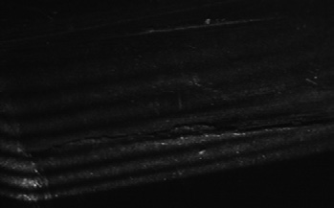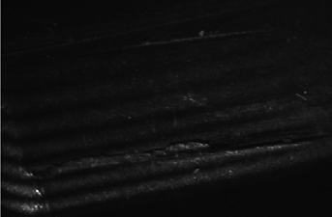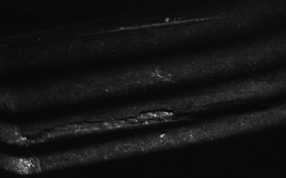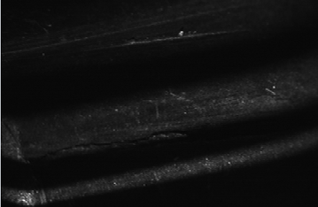

Fig. 4. A series of processing images

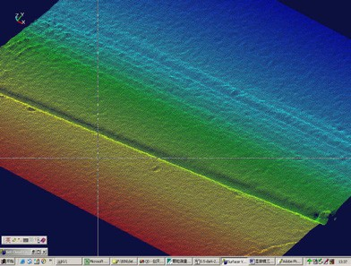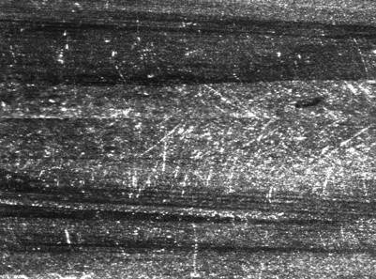This system has done experimental and applied tests in shot hole detection, files detection, trace detection, counterfeit coins detection, fingerprint feature recognition, etc. Fig 5.(Fig 5.(a): image display, Fig 5.(b): point cloud of the same object). In Fig 5.(a), the distinguish regional is not obvious. In Fig 5.(b), display different depths with different colors, the difference can be clearly observed. As shown in Fig 6, the depth difference between ridge and valley line is 0.03071 mm, the difference between two ridge lines is 0.3208 mm.

(a) (b)

Fig. 5. Warheads rifling

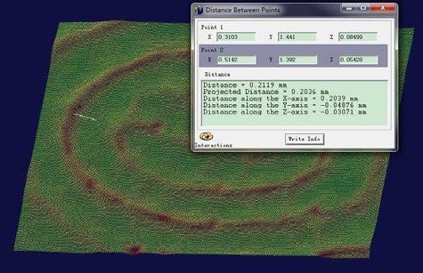 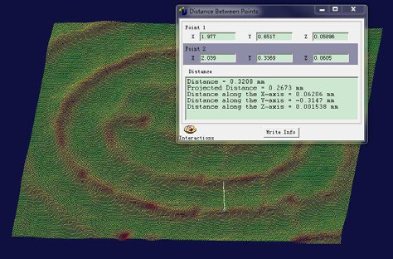

(a) (b)

Fig. 6. Fingerprint point cloud

1. Conclusion

This paper lead phase shift technology into the application of microscopic measurement. Combined stripe projection, CCD acquisition with mutative viewing range, it can reconstructed 3D information of objects accurately, in the viewing range of 1mm-20mm, the measurement error can be controlled within 1µm. Finally, prove the system is practical and accurate by application testing. This paper is a tentative applied study for obtaining 3D information in the microscopic viewing, although the system has gained good results, but also need to keep studying and improving.

References

1. Sylvain Petitgrand, Alain Bosseboeuf. The static and dynamic behavior of characterization of MEMS by optical techniques: trends and status. Journal of Microengineering and Micromechanics 2003;13:23-33.
2. Sane T, Yamameto H. Study of micromanipulation using stereoscopic microscope. IEEE Transactions on Measurement and Instrumentation 2002;51(2):182-187.